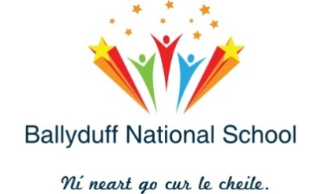
Ballyduff National School, Kilmeaden, Co. Waterford, X91 Y510.
Tel: 051384414 info@ballyduffns.com
Roll Number: 13635R
___________________________________________________________________
Staff 2019-2020

Teachers 2019-2020

Junior Infants Marie O’ Neill
Senior Infants Caroline Moore
First Class Patricia Power
Second Class Lorraine Moore (Clodagh Fitzgerald)
Third Class Pauric Stapleton
Fourth Class Darren Moynihan
Fifth Class Dawn Tyrrell
Sixth Class John Carey
Pre-School Leona Kennedy
Junior Special Fiona Whelan
Senior Special Christion Hutchinson
S.E.T./D.P. Mary Brennan
S.E.T. Deirdre Bates
S.E.T. Karen Power (Orla Mooney)
Principal Fionnuala Power

Special Needs Assistants 2019-2020

Pre-School Tommy Kiely
Sinéad Blanche
Junior Special Eileen O’ Leary
Stephanie Maguire
Senior Special Debbie Ledwell
Paula Fitzgerald
Roberta Kavanagh
5th Class Tríona Sinnott

Secretary Mary Heffernan
Caretaker Marc O’ Neill

