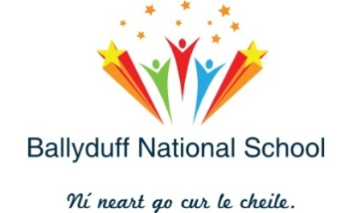
Ballyduff National School, Kilmeaden, Co. Waterford, X91 Y510.
Tel: 051384414 info@ballyduffns.com
Roll Number: 13635R
___________________________________________________________________
Staff 2020-2021

Teachers

Junior Infants Emma Sprice
Senior Infants Patricia Power
Infant Support Marie O’ Neill
First Class Deirdre Bates
Second Class Darren Moynihan
Third Class Caroline Moore (Clodagh Fitzgerald)
Fourth Class John Carey
Fifth Class Dawn Tyrrell
Sixth Class/DP Pauric Stapleton
Pre-School Lorraine Ryan
Junior Special Leona Kennedy
Senior Special Christion Hutchinson
S.E.T. Seamus Lavan / Fiona Whelan
S.E.T. Karen Power
Principal Fionnuala Power

Special Needs Assistants

Pre-School Tommy Kiely
Mary Burke
Junior Special Jennifer Cullinane
Stephanie Maguire
Senior Special Sinead Blanche
Paula Byrne
Roberta Kavanagh
Senior Infants Debbie Ledwell
6th Class Tríona Sinnott

Ancillary Staff

Secretary Mary Heffernan
Caretaker Marc O’ Neill
Cleaners Lisa O’ Keeffe
Declan O’ Keeffe
Bus Escorts Margaret Howard
Lisa Torpey

